Upper Turtle Lake District
August 2023 Newsletter

PO Box 461, Turtle Lake, WI 54889
Email: upperturtlelake@hotmail.com
Website: www.upperturtlelake.com
Facebook: https://www.facebook.com/upperturtlelake
Summer Fun at the Lake!
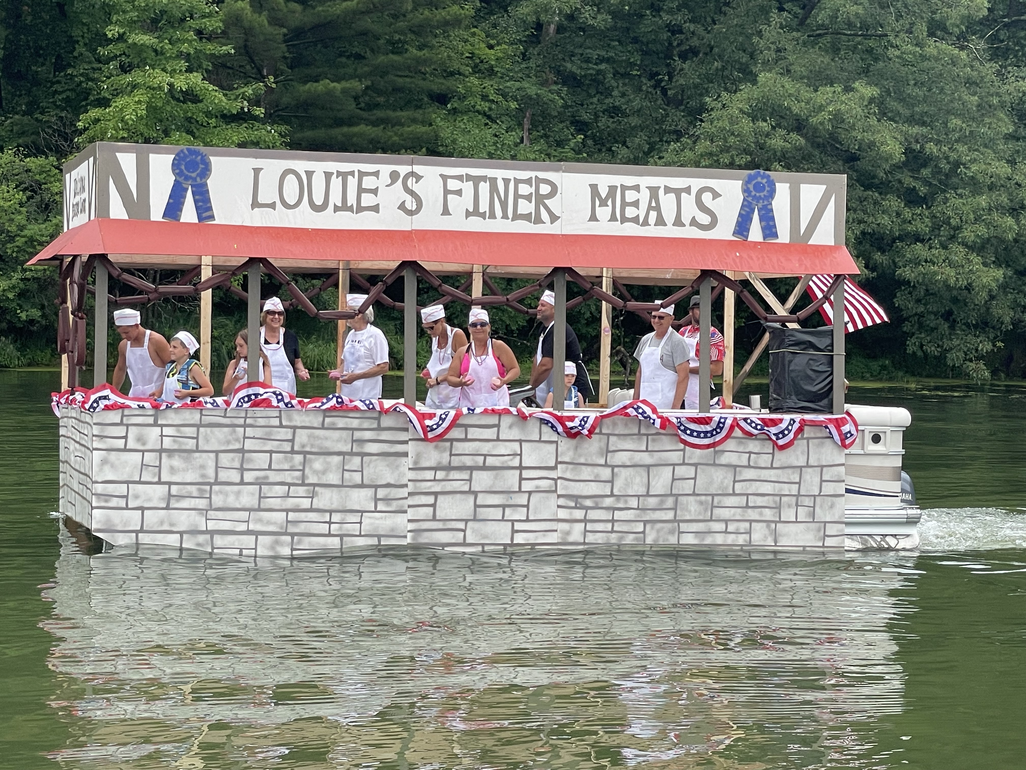
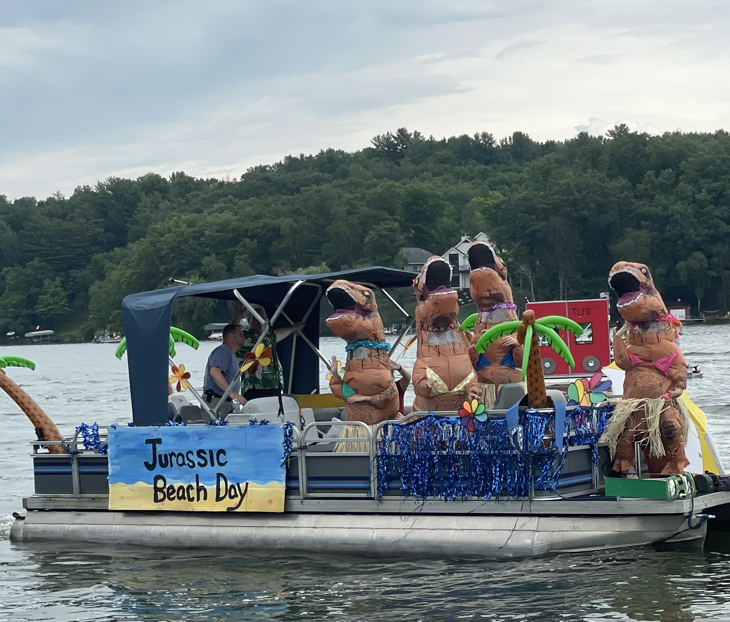
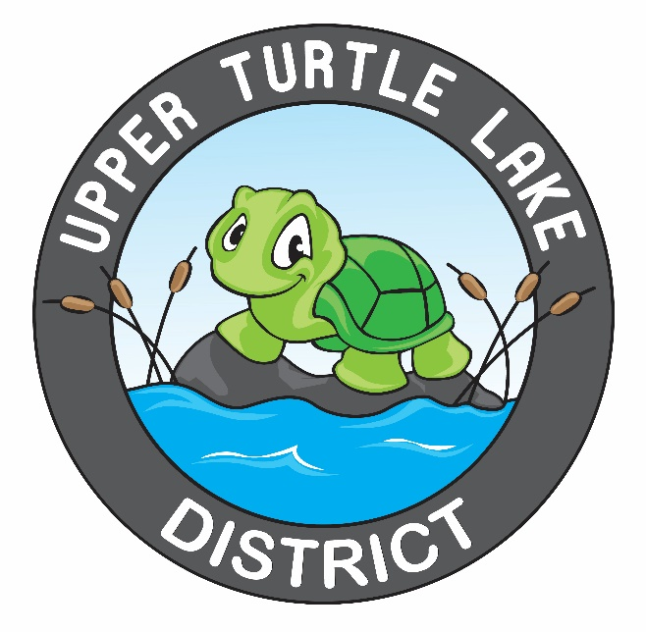
Upper Turtle Lake District’s 6th Annual Meeting:
Saturday, August 19th, 10:00 a.m. Ritsche Pavilion, Turtle Lake. Voting will take place on the 2024 Budget, 2024 Lending Authority, and Commissioner Election. Please come and support your Upper Turtle Lake District!

UTLD Commissioner Meeting:
September 15th, 9:00 a.m., Almena Village Hall, 131 Soo Avenue, Almena, WI

2023 Events
Congratulations to the Studnickas and the Millers! The Studnickas took the “Most Patriotic Float” award, and the Millers took the “Most Original Theme” award.

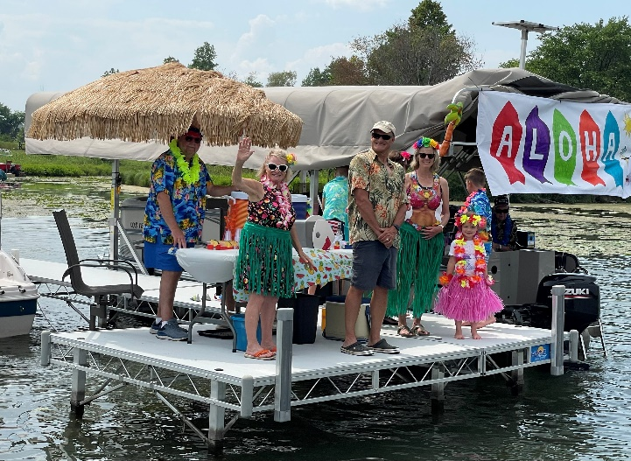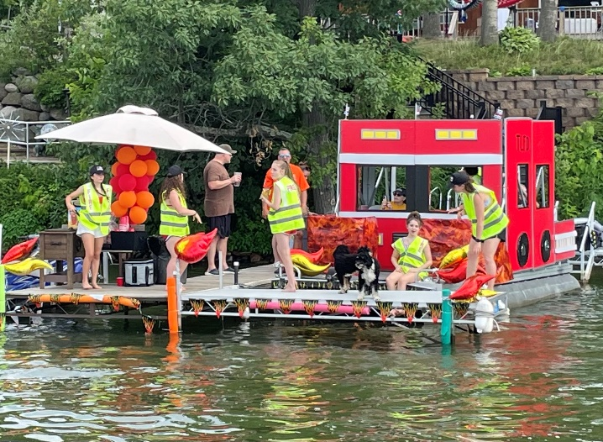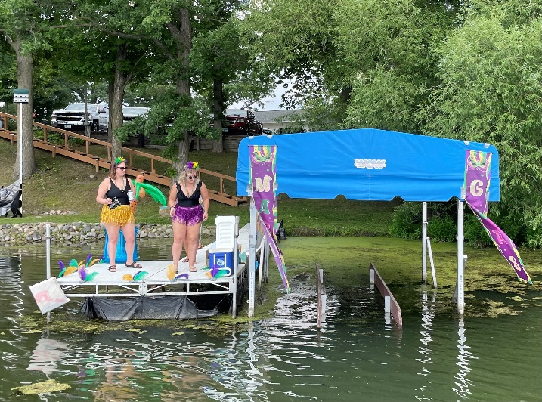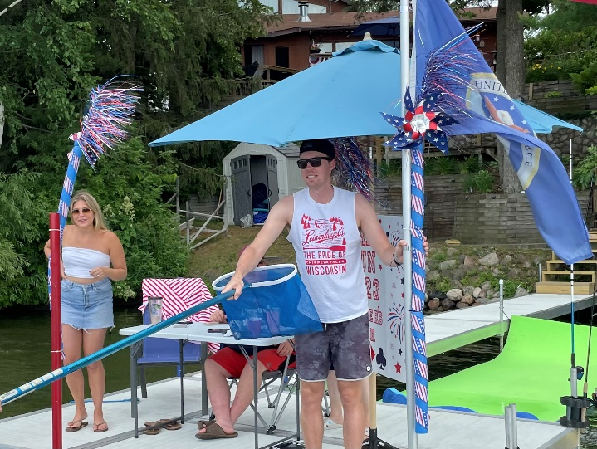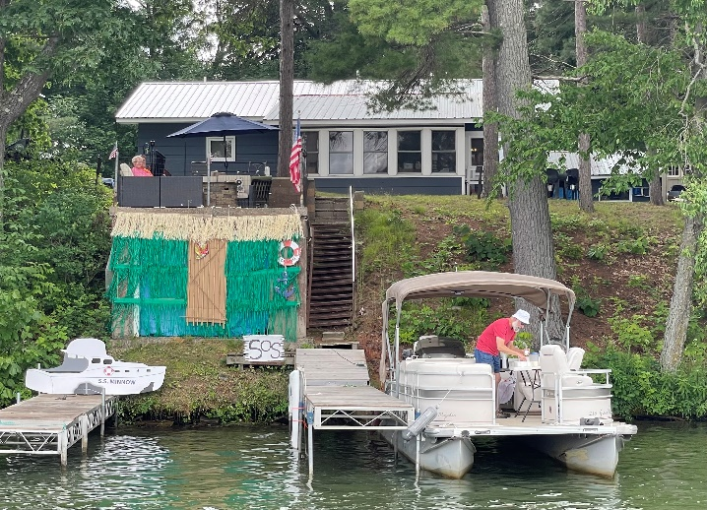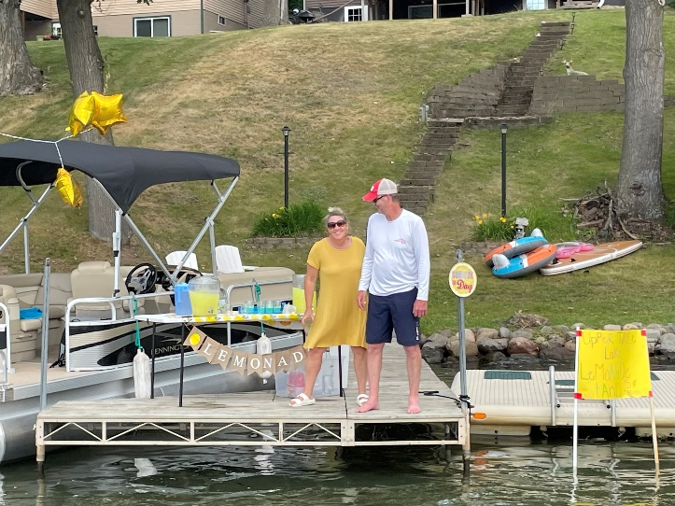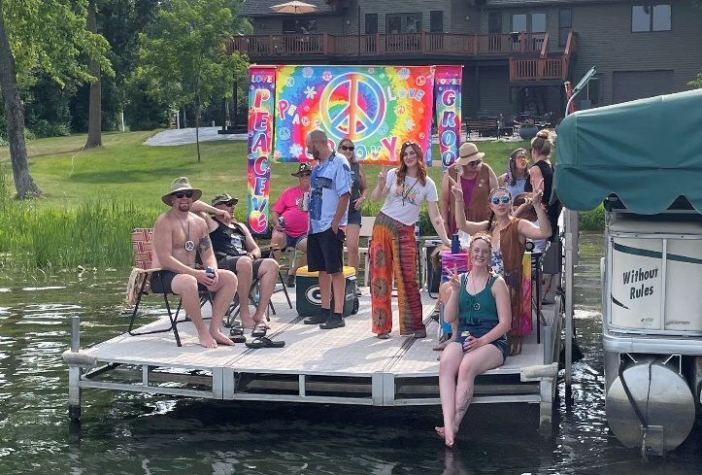Meet Your Neighbors/Poker Run!
The Poker Run was a great success again! 260 poker players visited 7 different docks, and were treated to different refreshments. A BIG Thank You to all the Dock Hosts: Gerbers (Gilligan’s Island), Arends (Lemonade Stand), Webers (Fire Department), Petersons (Hawaiian), Searles (Hippies), Bryants (Mardi Gras), and the McDonalds, (Card Dealers). The “Chicken Duo” music was also a success, and again, a BIG Thank You to the Wohlers, Koehnens, and Kruegers for hosting the band.
2023 Upper Turtle Lake District’s 6th Annual Meeting Notice and Agenda
Saturday, August 19th, 10:00 a.m., Ritsche Pavilion, Turtle Lake, Wisconsin
Welcome: John Vono, Introduction of Lake District Commissioners, New Homeowners, and Guests.
Voting Process Review: Carol Timmerman
Secretary’s Report: Carol Timmerman, Approve Annual Meeting Minutes from 2022.
Treasurer’s Report: Mike McCauley
Internal Audit Report: Internal Audit Team
2023 Accomplishments: John Vono
2024 Treatment Plan: John Vono
Voting:
2024 Budget: McCauley
Lending Authority: Vono
Commissioner Election: Timmerman
CBCW Update:
Boating Etiquette: Vono
Public Input/Questions:

Your UTLD Board
Board Chair: John Vono (651) 472-3560
Treasurer: Mike McCauley (612) 282-0624
Secretary: Carol Timmerman (507) 398-9995
Almena Township Rep: Ken Scheps (715) 296-5723
Barron Cty Board Rep: Jim Gores (715) 357-3720

2024 Proposed Upper Turtle Lake District Budget

Income:
Tax Revenues: 25,000
2023 Checking Account Carryover: 10,825
Other Income (Poker Run): 1575
CBCW Grant: 2450
Total Income: $39,850

Expenses:
Operating Expense: 3400
Advertising, printing, and postage: 1950
Social/Community Fund: 2200
Lake Consulting and Support: 4300
DNR Permit Application: 785
CLP Treatment: (16.9 acres): 14525
Aquatic Plant Mapping: 5095
Water Quality Testing: 420
CBCW Expenses: 2450
Decontamination Station (New): 4725
Total Expenses: $39,850

Notes from the UTLD Chair
Greetings Upper Turtle Lake District Residents! Hoping this newsletter finds everyone well and enjoying the summer. Our summer enjoyment usually includes time spent on, in, or near beautiful Upper Turtle Lake. It is what we look forward to during the long winters.
Recently the Lake District Commissioners have been receiving complaints about behavior on the lake. I would like to take this time to remind everyone of boat etiquette and being considerate to all residents. Most of the complaints received are related to loud and vulgar voices and music playing on boats. Please be considerate and mindful of all who are on or near the lake. There are many younger children within earshot. Remember as well that sound travels extremely well and far on the lake.
Complaints have also been received of cans, bottles, etc. thrown into the lake. Please take care to keep empty containers on board, and dispose of properly.
I also want to remind everyone to be courteous and follow boating rules and regulations for everyone’s safety and enjoyment. The Wisconsin Boating Handbook is located at wisconsin-handbook-entire.pdf (kalkomey.com).
Thanks for everyone’s cooperation, consideration, and engagement. I hope to see you at the upcoming Annual Meeting on Saturday, August 19th, 10:00 a.m. at the Ritsche Pavilion in Turtle Lake.

John Vono, UTLD Chair

CBCW Update
Excellent progress has been made in reaching the 2024 Clean Boats Clean Waters Grant goals! 88 of the 100 volunteer hours, and 57 of the 100 paid hours have been completed to date. Coverage through the rest of the year is needed, so please volunteer when you can! Contact Kim Swenson for more details. (kim.swenson2015@gmail.com)
A big shout out to Sharon Dunemann, Kim Swenson, Nancy Searle, Kari and Marc Kalis, Al and Julie Bauer, Carmen Crocker, Judy Schuch, Sonja Bjork, Kathy Preusse, Mike McCauley, and Michelle Stoffel for your time spent working the boat landing!

Lake District Commissioner Opening
The Lake District is looking for your help! Please consider volunteering your talents to keep the Upper Turtle Lake healthy and beautiful. A Lake District Commissioner position is open, and you are needed. You will learn so much about the lake, and will meet so many of your lake neighbors! Contact any of the current Commissioners if you have an interest.

.

